**Topic: Web browsers**

Reading Time: 15 mins

**·        Note* Highlight important/core points while reading**

·        Read the content and write the answers given in the document in your words, to get the solid grip on topic.

**Web Browsers**

A **web browser** is a software application used to access, retrieve, and display web pages and other online resources from the **World Wide Web (WWW)**. It allows users to navigate websites, interact with online content, and manage their browsing experience efficiently.

**Main Features of Web Browsers**

**1. Home Page**

* The **home page** is the first page that appears when the browser is opened.
* Users can set their preferred home page (e.g., www.google.com).

**2. Bookmarks (Favorites)**

* Browsers allow users to **save frequently visited web pages** as bookmarks.
* This makes it easier to access favorite websites quickly without typing the URL.

**3. Browsing History**

* The browser stores a **record of visited websites** (user history).
* Users can view and revisit previously accessed websites.

**4. Navigation Controls**

* Browsers provide **back and forward buttons** to move between previously opened web pages.
* Users can **refresh** a web page to reload updated content.

**5. Multiple Tabs**

* Users can open **multiple web pages** in a single browser using **tabs**.
* This allows efficient multitasking without opening separate windows.

**6. Cookies**

* Cookies are **small text files** stored on the user’s computer by websites.
* They store user preferences, login sessions, and browsing data.
* Example: A shopping website may use cookies to remember items in a cart.

**7. Hyperlinks and Navigation**

* Hyperlinks (or **links**) allow users to move between different web pages.
* A hyperlink can be opened in two ways:
  + **Same tab** → Click the link normally.
  + **New tab** → Press <Ctrl> + Click (Windows) or <Cmd> + Click (Mac).

**8. Cache Storage**

* Browsers store **cached data** (temporary files like images and scripts) to load websites faster on repeat visits.
* This reduces the need to download the same content multiple times.

**9. JavaScript Support**

* Web browsers can execute **JavaScript**, a programming language used to create **interactive** and **dynamic** web pages.
* Example: Forms, animations, and pop-up messages on websites are powered by JavaScript.

**10. Address Bar**

* The address bar is where users enter a website's **URL (Uniform Resource Locator)**.
* Some browsers provide **search suggestions** directly from the address bar.

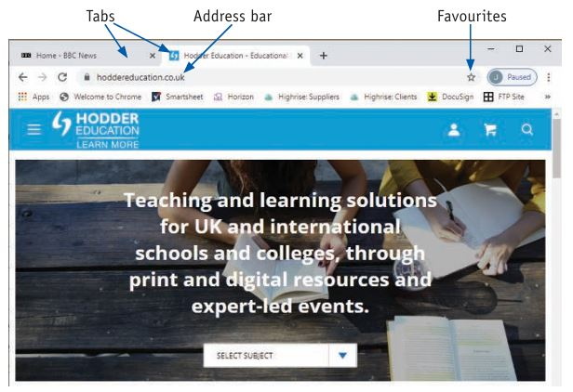

**A-Rated Questions/Answers By Examiner**

**Q1: What is a web browser, and what is its main function?**

**Answer:**A web browser is a **software application** used to access, retrieve, and display web pages on the **World Wide Web (WWW)**. Its main function is to interpret and render HTML documents, allowing users to **view websites, navigate links, and interact with online content**.

**Q2: What are bookmarks in a web browser, and why are they useful?**

**Answer:**Bookmarks (also called **favorites**) are stored shortcuts to frequently visited websites. They are useful because they allow users to **quickly access saved web pages** without needing to retype the URL.

**Q3: Explain how web browsers use cookies.**

**Answer:**Cookies are **small text files** stored on a user's device by websites. They are used to:

1. **Remember login details** (e.g., staying signed in).
2. **Store user preferences** (e.g., language settings).
3. **Track user activity** for personalized recommendations (e.g., targeted ads).

**Q4: What is the purpose of cache storage in a web browser?**

**Answer:**Cache storage temporarily saves **website data** (such as images, scripts, and stylesheets) on the user's device. This helps:

* **Load web pages faster** on repeat visits.
* **Reduce bandwidth usage** by avoiding repeated downloads.
* **Improve browsing performance**.

**Q5: How can a user open a hyperlink in a new tab?**

**Answer:**A user can open a hyperlink in a new tab by:

* Holding <Ctrl> (Windows) or <Cmd> (Mac) and clicking the link.
* Right-clicking the link and selecting **"Open in new tab."**

### Write your Answers on your Notebook and Verify it on Next Screen

**Q6: What are private browsing modes, and how do they work?**

**Q7: What is a browser extension, and how does it enhance web browsing?**

**Q8: What is a web browser’s user agent, and what is its purpose?**

**Q9: What are some common web browsers, and how do they differ?**

**Q10: How do web browsers handle security threats?**

**6. Answer:**

1. Private browsing (e.g., Incognito Mode in Chrome, Private Window in Firefox) prevents the browser from saving browsing history, cookies, and site data.
2. It helps users browse without leaving traces on their device.
3. However, private mode does not make users anonymous—ISPs and websites can still track activity.
4. It is useful for logging into multiple accounts or browsing sensitive information.

**7. Answer:**

1. A browser extension is a small software add-on that enhances browser functionality.
2. It allows users to customize their browsing experience (e.g., ad blockers, password managers, productivity tools).
3. Extensions run in the background and integrate with the browser to provide extra features.
4. They are available on browser-specific stores, such as the Chrome Web Store or Firefox Add-ons.

**8. Answer:**

1. A user agent is a string of text sent by the browser to websites, identifying the browser type and operating system.
2. Websites use user agents to adjust content for different devices and browsers.
3. Example: A mobile website version may be displayed when a user agent indicates a smartphone.
4. Developers can modify user agents for testing website compatibility.

**9. Answer:**

1. **Google Chrome** – Fast, widely used, supports many extensions.
2. **Mozilla Firefox** – Privacy-focused, open-source, customizable.
3. **Microsoft Edge** – Built on Chromium, integrated with Windows.
4. **Apple Safari** – Optimized for macOS and iOS, energy-efficient.
5. **Opera** – Built-in VPN and ad blocker, customizable UI.

**10. Answer:**

1. **Phishing protection** – Warns users about suspicious websites.
2. **Sandboxing** – Isolates web pages to prevent malicious code from affecting the system.
3. **Automatic updates** – Patches security vulnerabilities.
4. **Blocking insecure content** – Prevents mixed-content loading (HTTP content on HTTPS sites).
5. **Permission controls** – Asks users before allowing access to the camera, microphone, or location.